Share your Ideas and Knowledge!
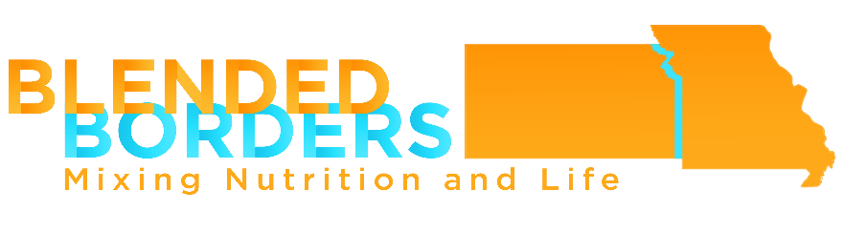
Call for Poster Sessions Abstracts
KSAND & MOAND Joint Conference
April 6 & 7, 2018
Marriott Kansas City
Overland Park, Kansas

The poster session provides an opportunity to share with colleagues from across the Midwest region projects that are innovative and effective. Poster displays can include information obtained from formal research projects as well as best practices that have been successful in achieving outlined goals with measurable outcomes.

1. Poster Session Display
This will be a visual presentation of a program or activity that has successfully achieved project goals with measurable outcomes. You will be expected to attend your poster during all exhibit/poster times during the conference and be able to speak and answer questions about your poster articulately.

2. Abstract Form (please attach the abstract to this registration form)
One page abstract (1-2 paragraphs) should include, but are not limited to:
- Title and Author(s)
- Objective – narrative description of project
- Methods – brief description of the program or project
- Results – outcome measures
- Summary – benefits of sharing project with peers

- Display Space and Equipment
In order to display a poster you must register as a Poster Session Presenter for the Friday & Saturday, April 6 & 7th conference. Your registration fee will be 50% off the early-bird price. Posters will be displayed on easels within the conference space. Poster displays should be mounted on foam/poster board and no larger than 2’x3’. The presenter will be responsible for setting up poster on easel at designated session times.

Abstract Submission Form
This is a fill-in form which enables data entry in text fields only (double-click to fill) OR you may complete online at https://goo.gl/forms/mnhpEQNvHXZqribx1
For your convenience, please submit this completed form with your abstract to:
Cara Harbstreet, MS, RD, LD at confprogram@eatrightks.org

Today’s Date | / / | Daytime Phone | ( ) - ext.
Name  (First, Last) (Credentials) | , | Email Address
Title of Poster
Street Address |  | City / State Zip code |  | ,
Will you be providing your own easel? | Y N | Special Needs:

Deadline Extended: February 15, 2018. The KSAND & MOAND Planning Committee will notify you of acceptance before March 15th.

