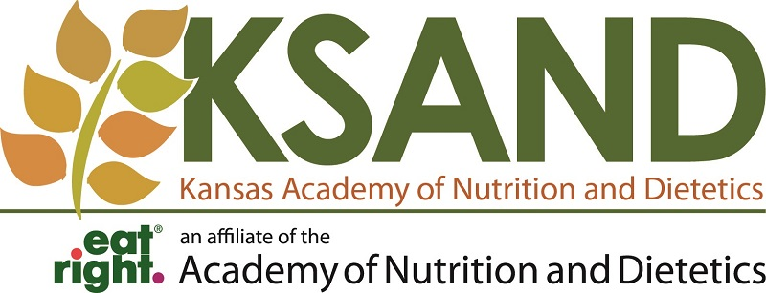

Kansas Academy of Nutrition and Dietetics
2018-2019 Nutrition Education Grant Application Form

KSAND Member Name:
Academy Member ID#:
Home Address:
Phone Number:
Email:
Project Date and Time:
Project Location:
Project Provider (company, association, individual):
Estimated # of participants:
Project Idea (Please be as detailed as possible with supporting material if available):

Please send to Stephanie Becker: AwardsChair@eatrightks.org
Email subject: Nutrition Education Grant Application

KANSAS ACADEMY OF NUTRITION AND DIETETICS
CHECK REQUEST FORM
Date: _________________
Payable To: |  | Amount of Check: | $
 |  | Mail Check to:
FEIN/SS#
The FEIN/SS# must match “Payable to” individual or company |  | In Payment of: | Education Grant Program

Requested By: ____________________________ Approved By: ______________________________

Instructions
Complete the check request form.
If your district association is to be reimbursed, please provide the tax ID number.
If you are personally getting reimbursed, you must provide your social security number OR a EIN number and the name of the business.
Send Check Request form to Director@eatrighks.org
If you are providing your personal social security number on this form, you can mail to:
Kansas Academy of Nutrition and Dietetics, Inc.
1508 W. 18th Avenue
Hutchinson, KS 67502

