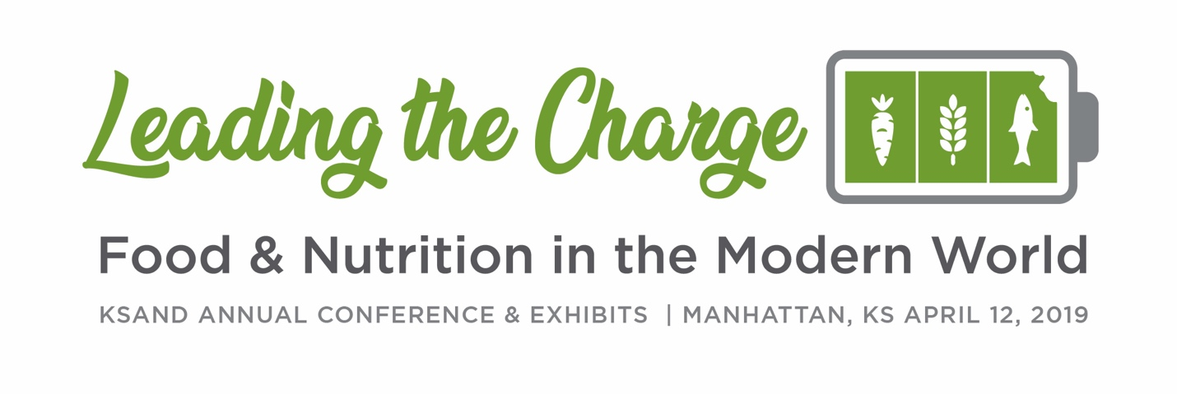

Thursday, April 11, 2019
10:00 a.m. – 11:00 a.m.  Room TBD | KSAND Executive Board Meeting
11:00 a.m. – 1:00 p.m.  Room TBD | KSAND Board Meeting
1:30 p.m. – 3:30 p.m.  Room TBD | Pre-conference Workshop*
4:00 p.m. – 6:00 p.m.  Room TBD | Conference Registration and Packet Pickup
6:30 p.m. – 8:30 p.m.  Room TBD | Fundraising and Networking Event*  Description  Schedule of Events:  Time Activity  Sponsors:
* Fee not included in conference registration

Friday, April 12, 2019
7:00 a.m. – 9:00 a.m.  Room TBD | Conference Registration
8:00 a.m. – 3:00 p.m.  Room TBD | Exhibits (setup prior to 8am)
7:00 a.m.  Room TBD | Western Kansas Dietetic Association Meeting
7:00 a.m. – 8:00 a.m.  Location TBD | Breakfast Buffet  Sponsor:
7:30 a.m. – 8:00 a.m.  Room TBD | Opening Ceremonies
8:00 a.m. – 9:00 a.m.  Room TBD | Opening Keynote Presentation  Title  Description  Presenter
9:00 a.m. – 9:05 a.m.  Room TBD | Break
9:05 a.m. – 10:05 a.m.  Room TBD  Room TBD | Breakout Sessions  Title  Description  Presenter  Title  Description  Presenter
10:05 a.m. – 11:05 a.m. | Exhibits and Poster Presentations
11:05 a.m. – 12:05 p.m.  Room TBD | Mid-Morning Keynote Presentation  Title  Description  Presenter
12:05 p.m. – 12:10 p.m.  Room TBD | Break
12:10 – 12:40 p.m.  Room TBD | Awards Ceremony and Member Business Meeting
12:40 p.m. – 1:40 p.m. | Luncheon and Networking  Sponsor: Kansas Beef Council
1:40 p.m. – 2:40 p.m.  Room TBD | Luncheon Keynote Presentation  Title  Description  Presenter
2:40 p.m. – 3:10 p.m.  Room TBD | Break—Silent Auction closes at 3:00 pm
3:10 p.m. – 4:10 p.m.  Room TBD  Room TBD | Breakout Sessions  Title  Description  Presenter  Title  Description  Presenter
4:10 p.m. – 4:15 p.m.  Room TBD | Break
4:15 p.m. – 5:15 p.m.  Room TBD | Closing Keynote Presentation  Title  Description  Presenter
5:15 p.m. – 5:30 p.m.  Room TBD | Closing Ceremonies

