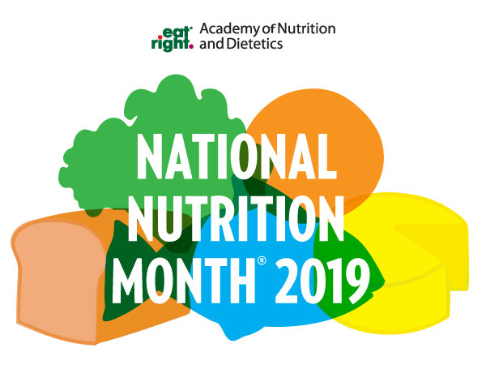

Do you have a project idea for National Nutrition Month®? The Kansas Academy of Nutrition and Dietetics is proud to offer funding to KSAND members to support the planning and implementation of two NNM projects. National Nutrition Month® is a great way to educate and promote the importance of living a healthy lifestyle.
This year’s campaign is honoring National Nutrition Month® as its own theme, which will allow for greater flexibility in the promotion of healthful messages. Plus, it allows the campaign to focus on its original purpose, which is: "To increase the public's awareness of the importance of good nutrition and position Academy members as the authorities in nutrition."
As nutrition experts, Academy members can help guide the public on gradually shifting toward healthier eating styles by promoting NNM activities and messages during March. Please see grant details for complete information on how to apply.
Grant amount: $125
Grant Deadline: February 15, 2019
NNM Grant Criteria:
- Must be a member of KSAND to apply.
- Must be a National Nutrition Month® 2019 theme project.
- The project is not limited to a specific style but must be in the guidelines given by the Academy (https://www.eatright.org/food/resources/national-nutrition-month).
- If awarded the grant, please submit a brief summary and photo for publication upon completion of the project. Email summary and photo to Gretchen Stroberg at Director@eatrightks.org by March 29, 2019, to be used in the KSAND Communicator, KSAND Facebook page and Twitter account.
- Must have a poster-board session at the KSAND Annual Conference and Exhibits on April 12, 2019, if your project is selected. See Poster Session Proposal information HERE. Note: if student members are awarded the grant the name of their major professor (credential practitioner) must be on the poster.
- Complete the KSAND NNM Grant Application and send to Kyleen Harris at NNMChair@eatrightks.org by February 15, 2019.

Kansas Academy of Nutrition and Dietetics
National Nutrition Month® Grant Application Form

KSAND Member Name:
Home Address:
Phone Number:
Email:
Project Date and Time:
Project Location:
Project Provider: (company, association, individual)
Estimated # of participants:
Project Idea: (Include a summary of anticipated expenditures. Please be as detailed as possible with supporting material if available)

Please send to Kyleen Harris: NNMChair@eatrightks.org
Email subject: NNM Grant Application
Due Date: February 15, 2019
KANSAS ACADEMY OF NUTRITION AND DIETETICS
CHECK REQUEST FORM
Date: _________________
Payable To: |  | Amount of Check: | $125
 |  | Mail Check to:
FEIN/SS#
In Payment of: | NNM Grant Program

Requested By: ____________________________ Approved By: ______________________________

Instructions
Complete the check request form.
If your district association is to be reimbursed, please provide the tax ID number.
If you are personally getting reimbursed, you must provide your social security number OR EIN number and the name of the business.
Send Check Request form to NNMChair@eatrightks.org
If you are providing your personal social security number on this form, you can mail to:
Kansas Academy of Nutrition and Dietetics
1508 W. 18th Avenue
Hutchinson, KS 67502

